**Logging Mechanism:**

* Enable & Disable Logging mechanism in our Murata Studio Application -

**Enable/Disable Log By Developers :**

* Developers can access the solution and enable it by Launching the application -
* **Murata => Properties => Debug => Command Line Arguments => /. /. /log**

For Example:

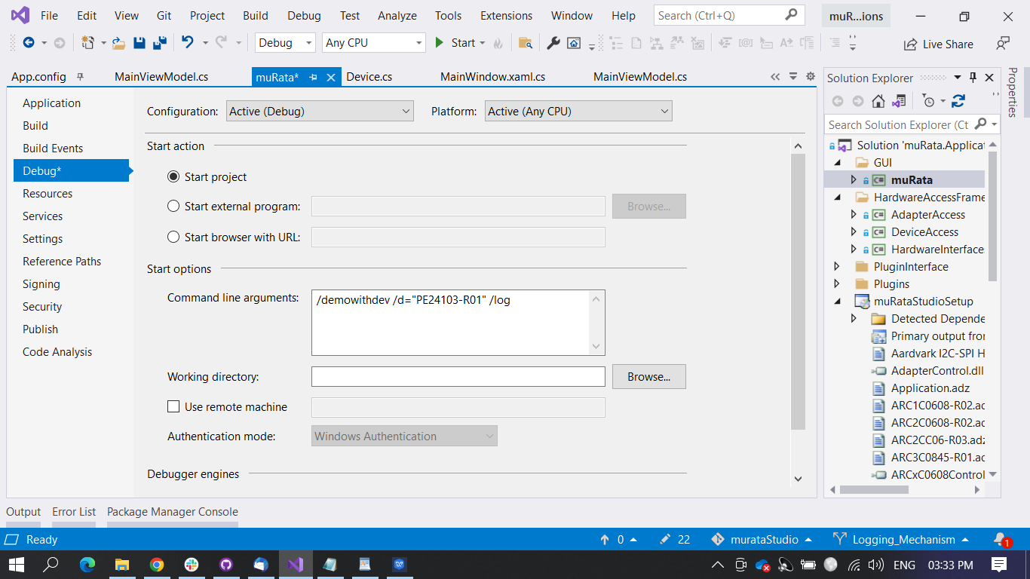

* Log will be enabled when we launch the application only by using this command line argument.

**Enable/Disable Log By Clients:**

* Client cannot enable this log using visual studio.
* Client enables log mechanism by installing the package.
* In the Murata Studio application **Shortcut => properties => Target => "C:\Program Files (x86)\muRata Corporation\muRata Studio\muRataStudio.exe"**
* If client want to load PE24103 device in demowithdev mode and enable log, then append **/demowithdev /d="PE24103-R01" /log**

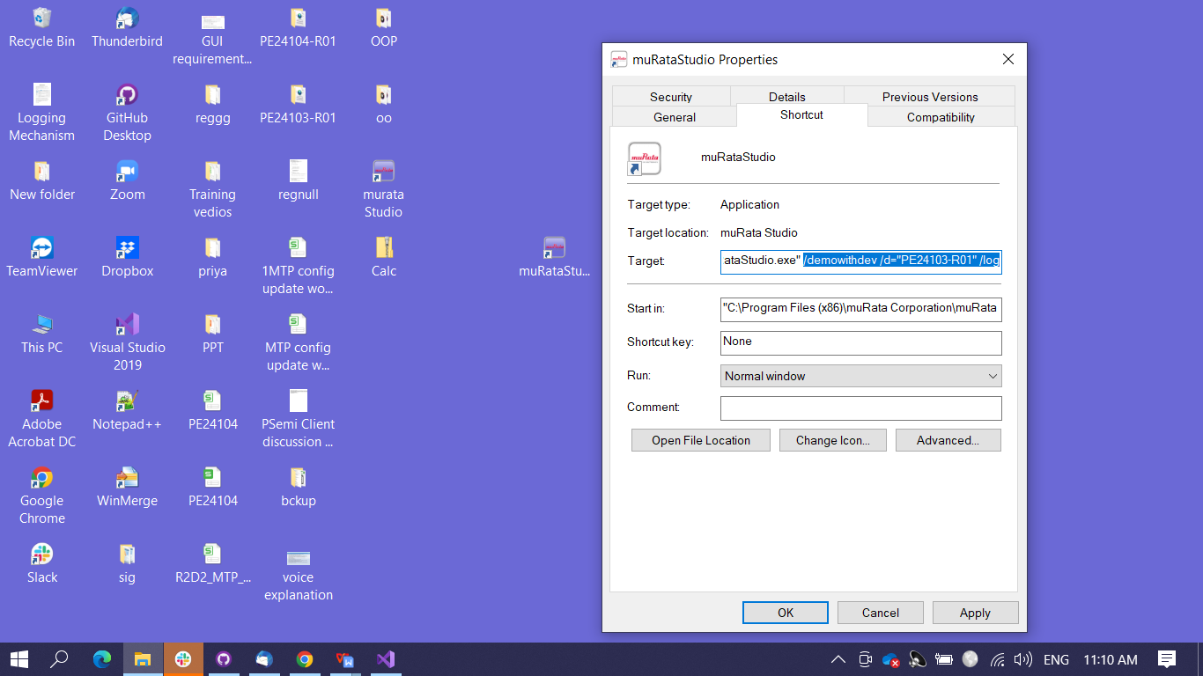

* Once Log enabled then application will get traced and Write - Exceptions, Events, Trace Information to the application log file:
* **Debug, Information, Error** Messages are logged in a file which can be found in C Drive.
* File Path: **C:\Logs\MurataAppLogs2022.log**
* Using Log, we can make a great impact in our application-
* 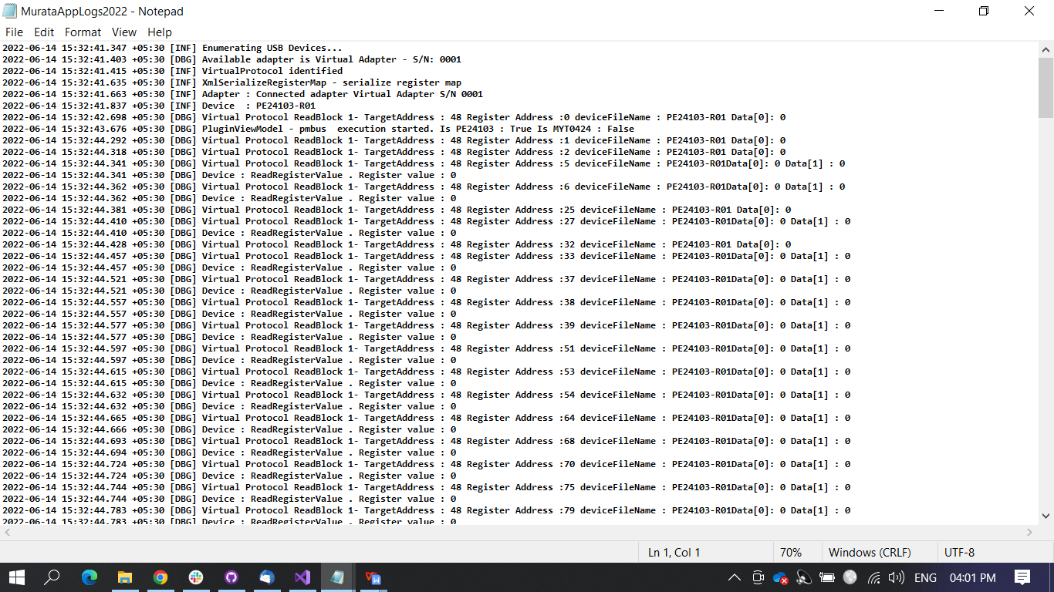It helps to monitor/trace back to the root cause of the Issue/ Error/ Exception and makes our debugging easier.

Picture shown above is log file which has error, debug, information message .